**BHU Admission Website – (User Manual)**

This guide will help administrators manage the website using Strapi.

# 1. Login (Strapi Admin Panel)

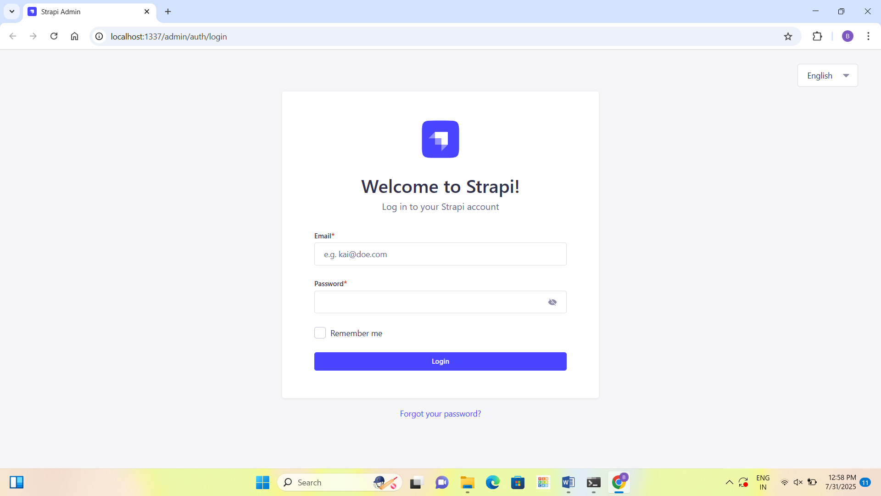

**Steps:**

**URL: api.bhu.edu.in**

* Open the login page.
* Enter your **Email** and **Password**.
* Click on the **Login** button.

# 2. About Us Section

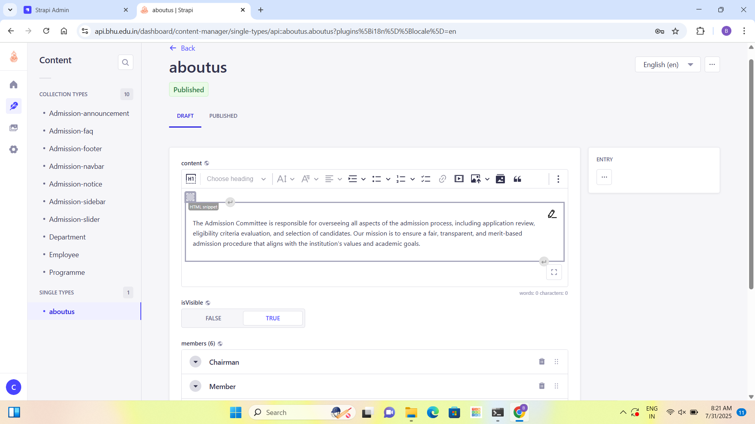

**Steps:**

* Go to 'about us' under SINGLE TYPES.
* Add the description of the admission committee in the editor.
* Add committee members and their details.
* Make sure 'isVisible' is TRUE to display on website.
* Click 'Save' and then 'Publish'.

# 3. Announcements

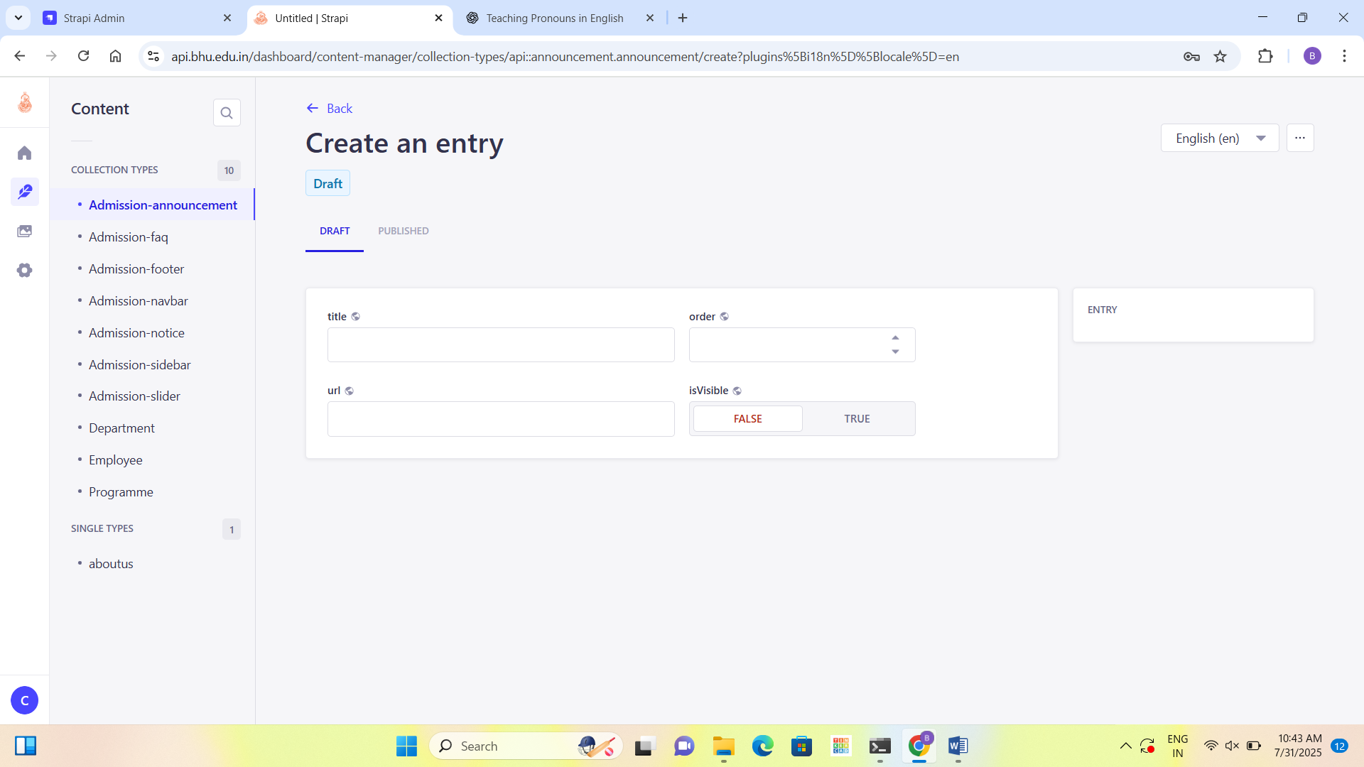

**Steps:**

* Go to 'Admission-announcement'.
* Click on 'Create new entry'.
* Add a title and URL for the announcement.
* Set the display order and make 'isVisible' TRUE.
* Click 'Save' and then 'Publish'.

# 4. FAQs

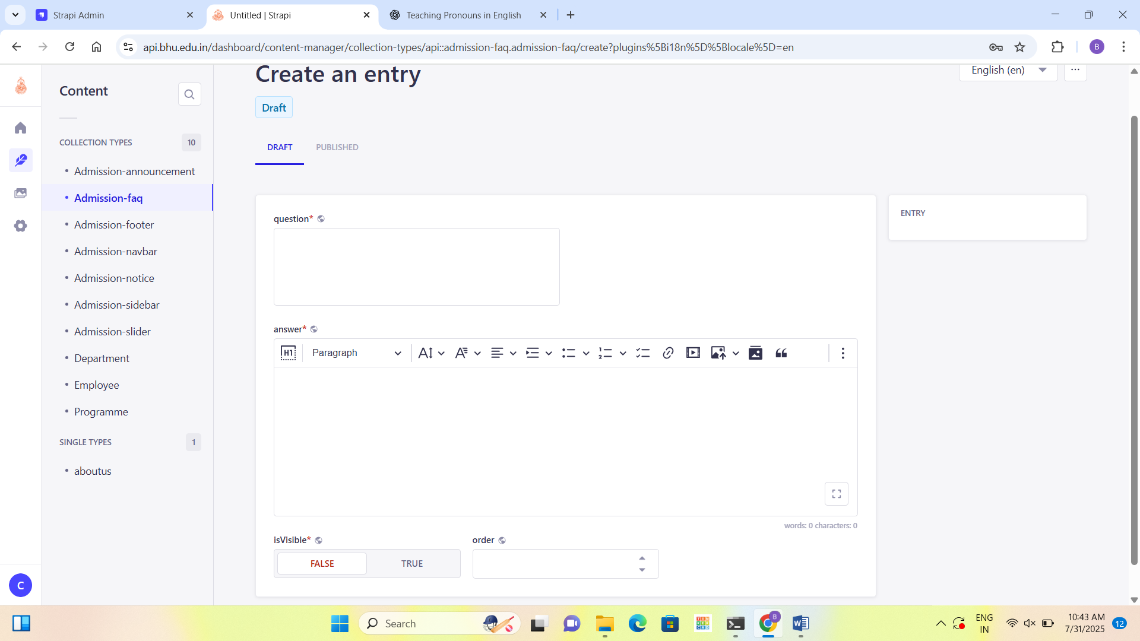

**Steps:**

* Go to 'Admission-faq'.
* Click on 'Create new entry'.
* Add your question and answer.
* Make 'isVisible' TRUE to show it.
* Click 'Save' and 'Publish'.

# 5. Navbar Menu

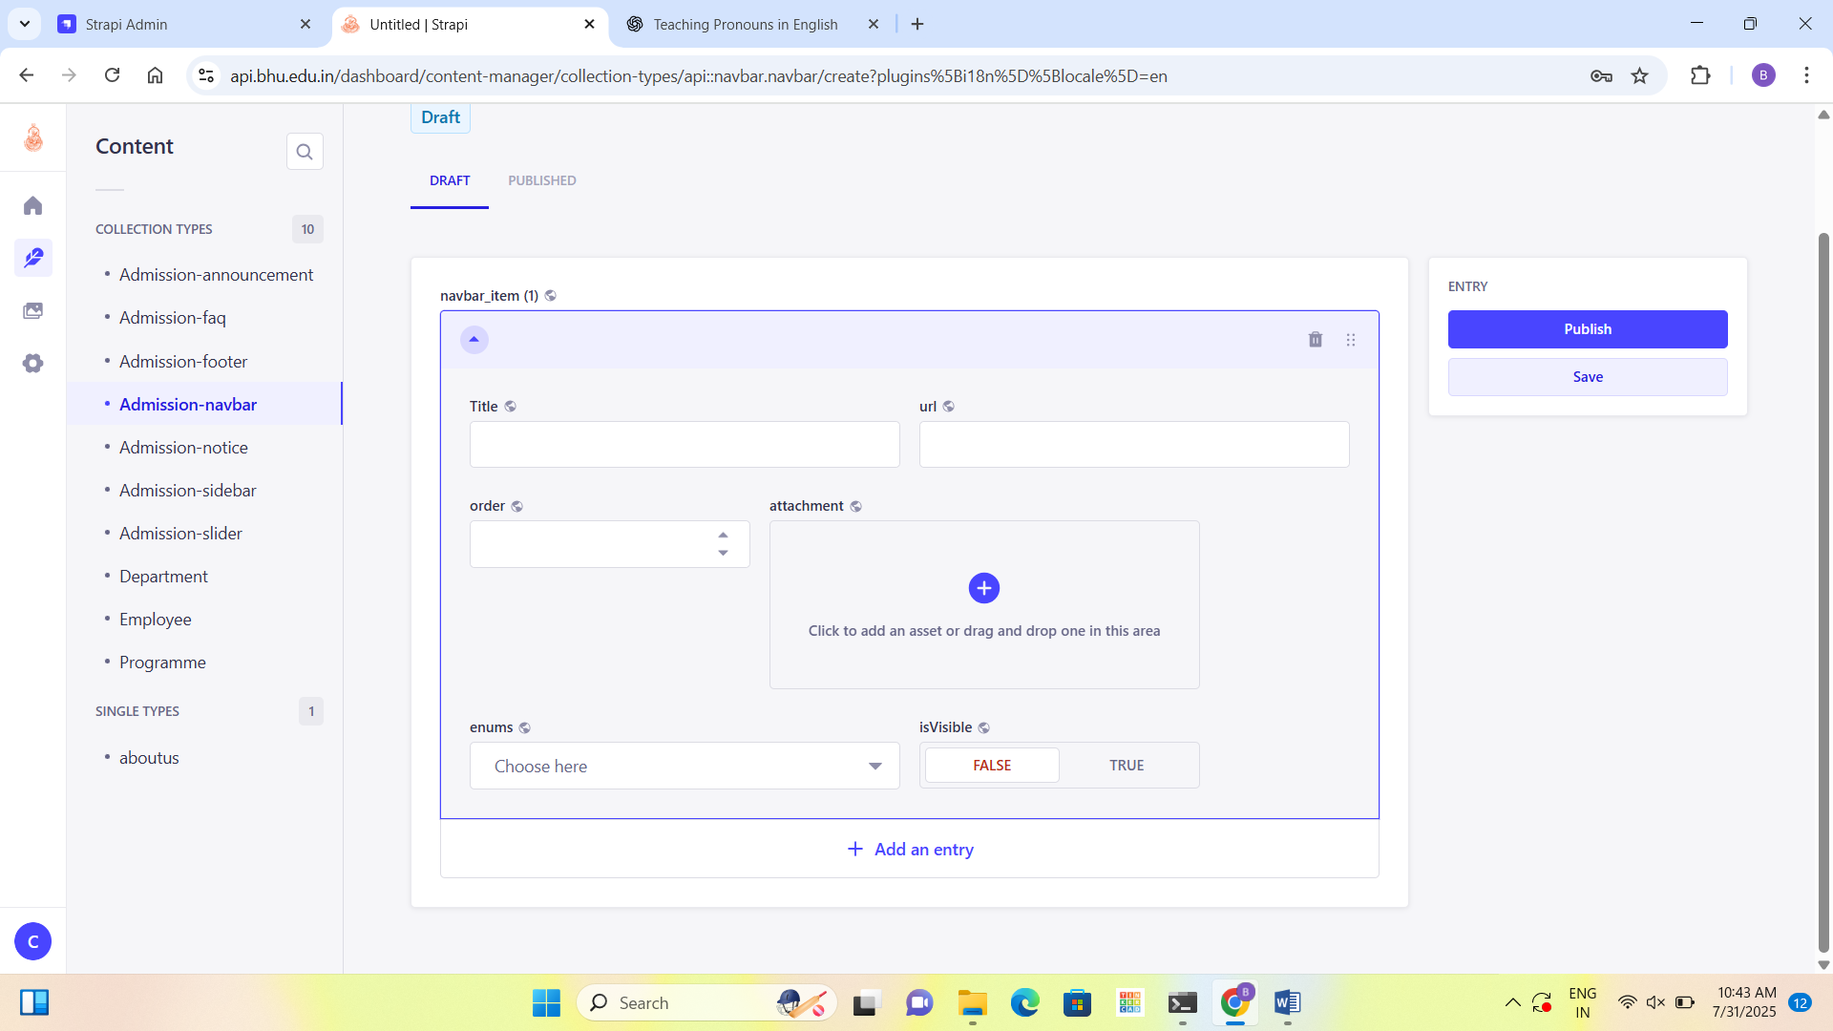

**Steps:**

* Go to 'Admission-navbar'.
* Click on 'Create new entry'.
* Enter title and URL for each menu item.
* Set order and upload icon if needed.
* Click 'Save' and 'Publish'.

# 6. Footer Section

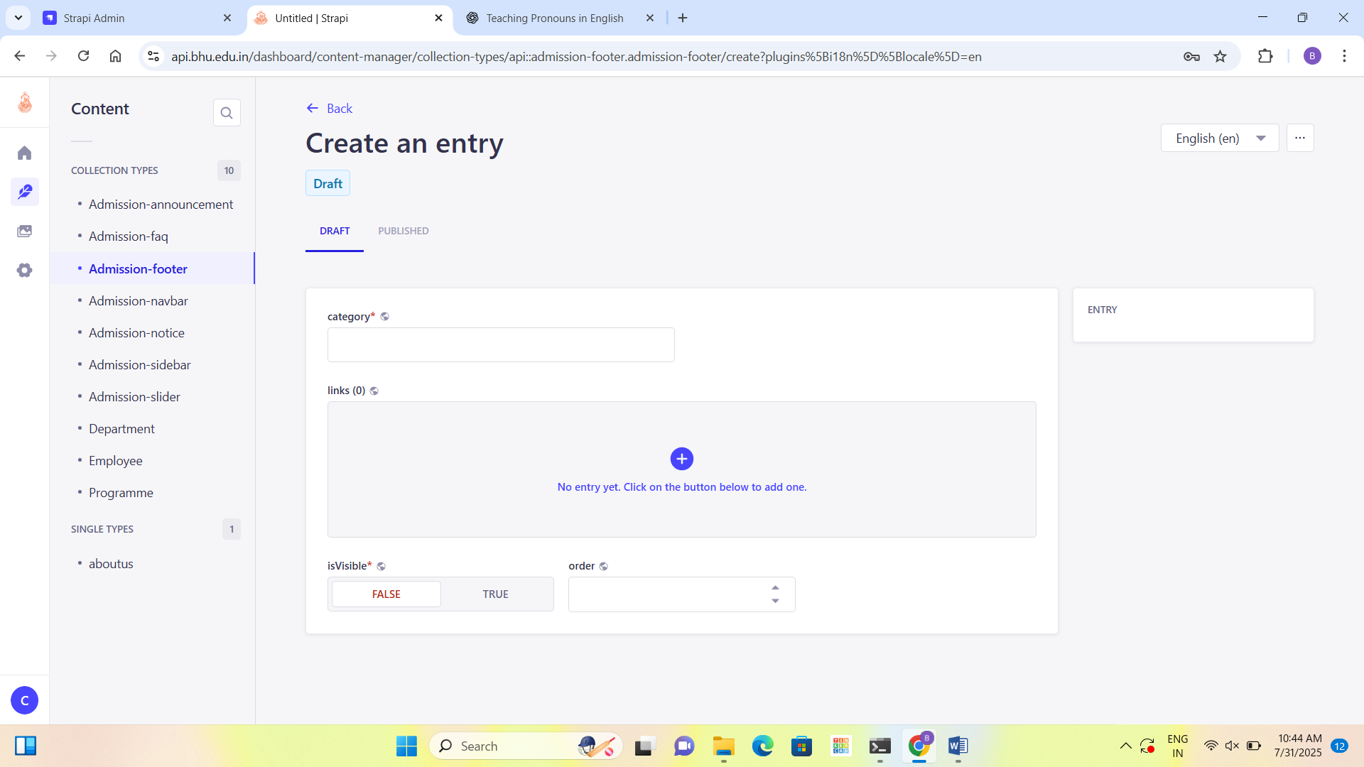

**Steps:**

* Go to 'Admission-footer'.
* Add footer category (like Quick Links).
* Add individual links under the category.
* Make sure 'isVisible' is TRUE.
* Set the order.
* Click 'Save' and 'Publish'.

# 7. Notices

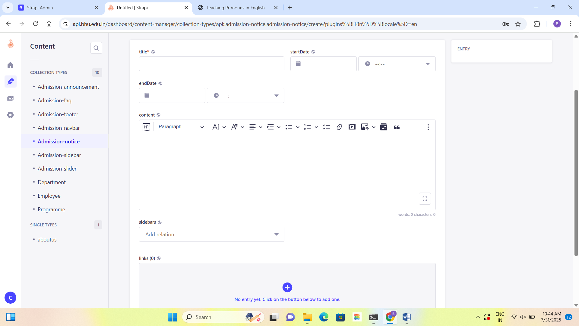

**Steps:**

* Go to 'Admission-notice'.
* Click 'Create new entry'.
* Add notice title, start and end date, and content.
* Add related links (PDFs or URLs).
* Make sure 'isVisible' is TRUE.
* Click 'Save' and then 'Publish'.

# 8. Add Links to Notices

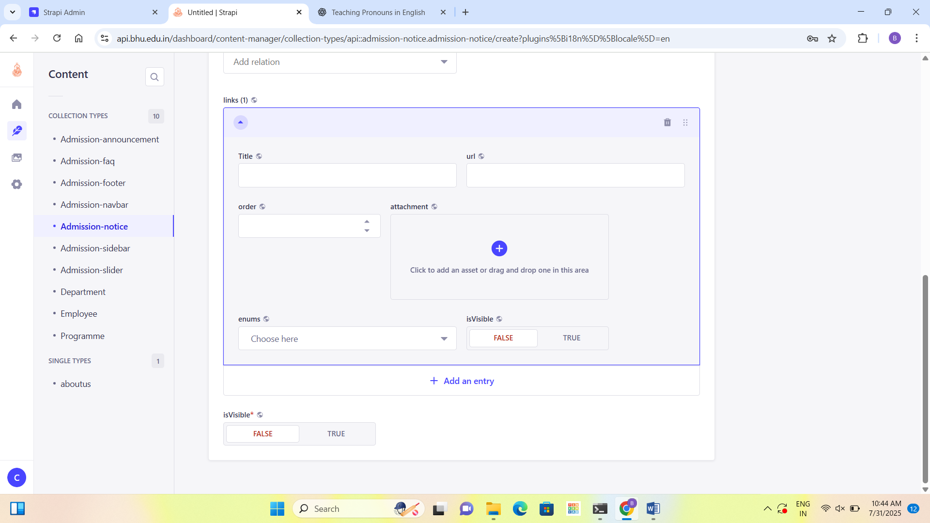

**Steps:**

* Scroll to 'links' section.
* Add title and file upload link.
* Set visibility and order for the link.
* Click 'Save' and 'Publish'.

# 9. Sidebar Content

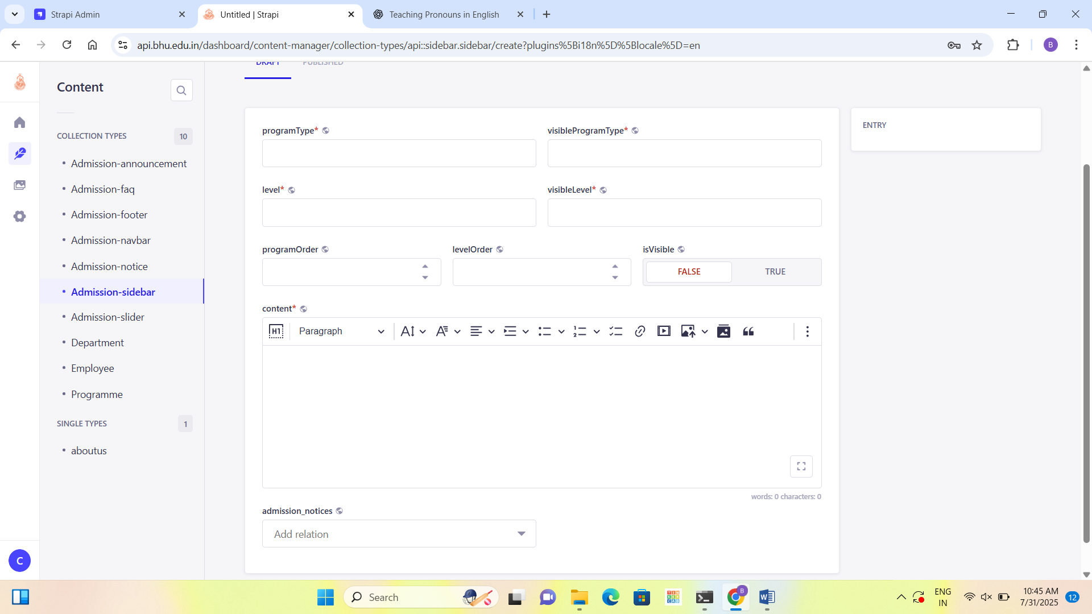

**Steps:**

* Go to 'Admission-sidebar'.
* Add program type and level (e.g., UG, PG).
* Write content and add related notice if any.
* Toggle visibility to TRUE.
* Click 'Save' and 'Publish'.

# 10. Slider Banner

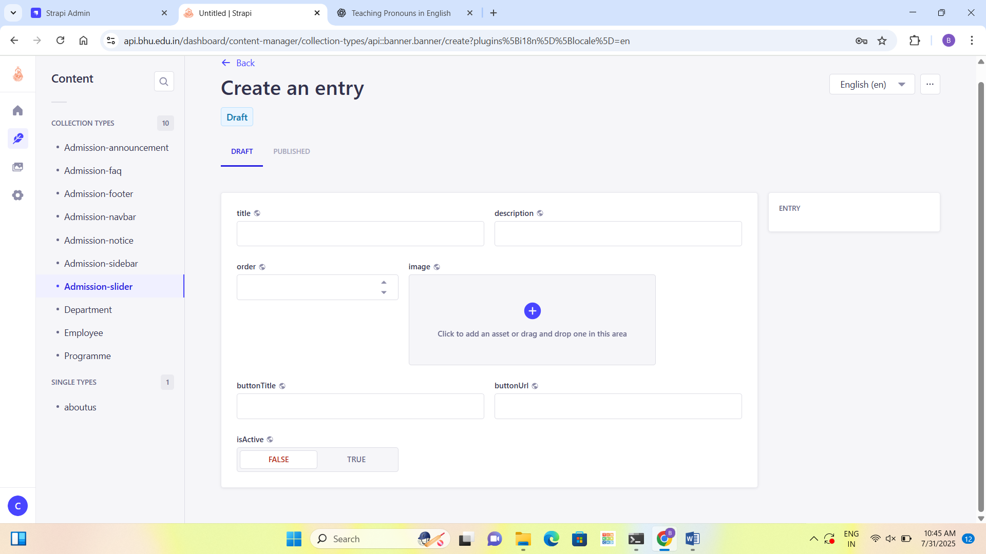

**Steps:**

* Go to 'Admission-slider'.
* Click 'Create new entry'.
* Add title, description, image, and button link.
* Make sure 'isActive' is TRUE.
* Click 'Save' and 'Publish'.

# 11. Upload Slider Images

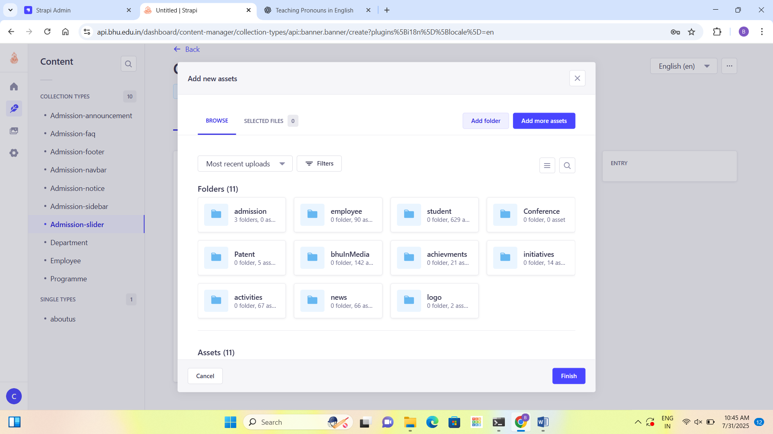

**Steps:**

* Click on the image upload area.
* Choose a folder or create a new one.
* Drag and drop or browse files to upload.
* Click 'Finish' and then 'Publish'.

**Note: -**

* Department, Employee and Programme Section Data will be fetched by the ERP Section (Currently Samarth)
* These sections are read-only for admin users.